RESERVOIR GEOMETRY

The shape of a reservoir has a significant effect on its flow behavior. Most reservoirs have irregular boundaries and a rigorous mathematical description of geometry is often possible only with the use of numerical simulators. For many engineering purposes the actual flow geometry may be represented by one of the following flow geometries:

• Radial flow
• Linear flow
• Spherical and hemispherical flow

Linear Flow

Linear flow occurs when flow paths are parallel and the fluid flows in a single direction. In addition, the cross sectional area to flow must be constant.

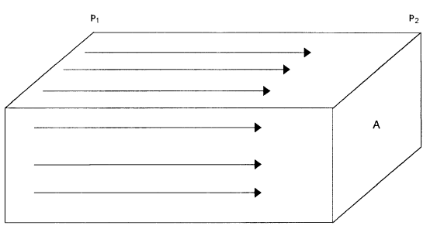

Figure-1. Linear Flow

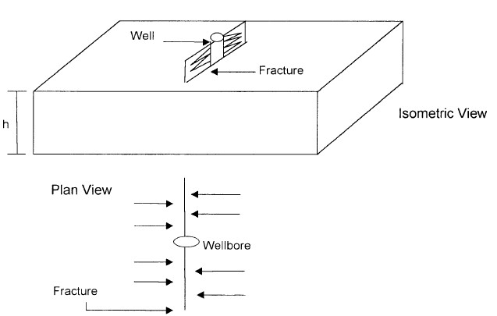

Figure -2. Ideal linear flow into vertical fracture.

Linear Flow of Incompressible Fluids

In the linear system, it is assumed the flow occurs through a constant cross-sectional area A, where both ends are entirely open to flow. It is also assumed that no flow crosses the sides, top, or bottom. If an incompressible fluid is flowing across the element dx, then the fluid velocity v and the flow rate q are constants at all points. The flow behavior in this system can be expressed by the differential form of Darcy’s equation

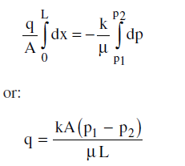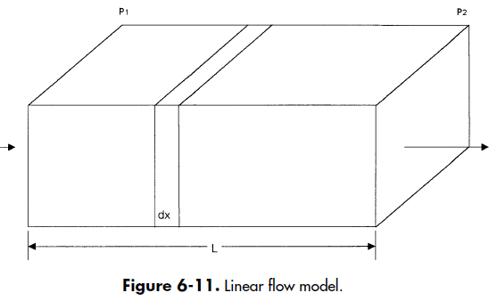

K - permeability, q – flow rate, p- pressure, L- length, A –cross sectional area.
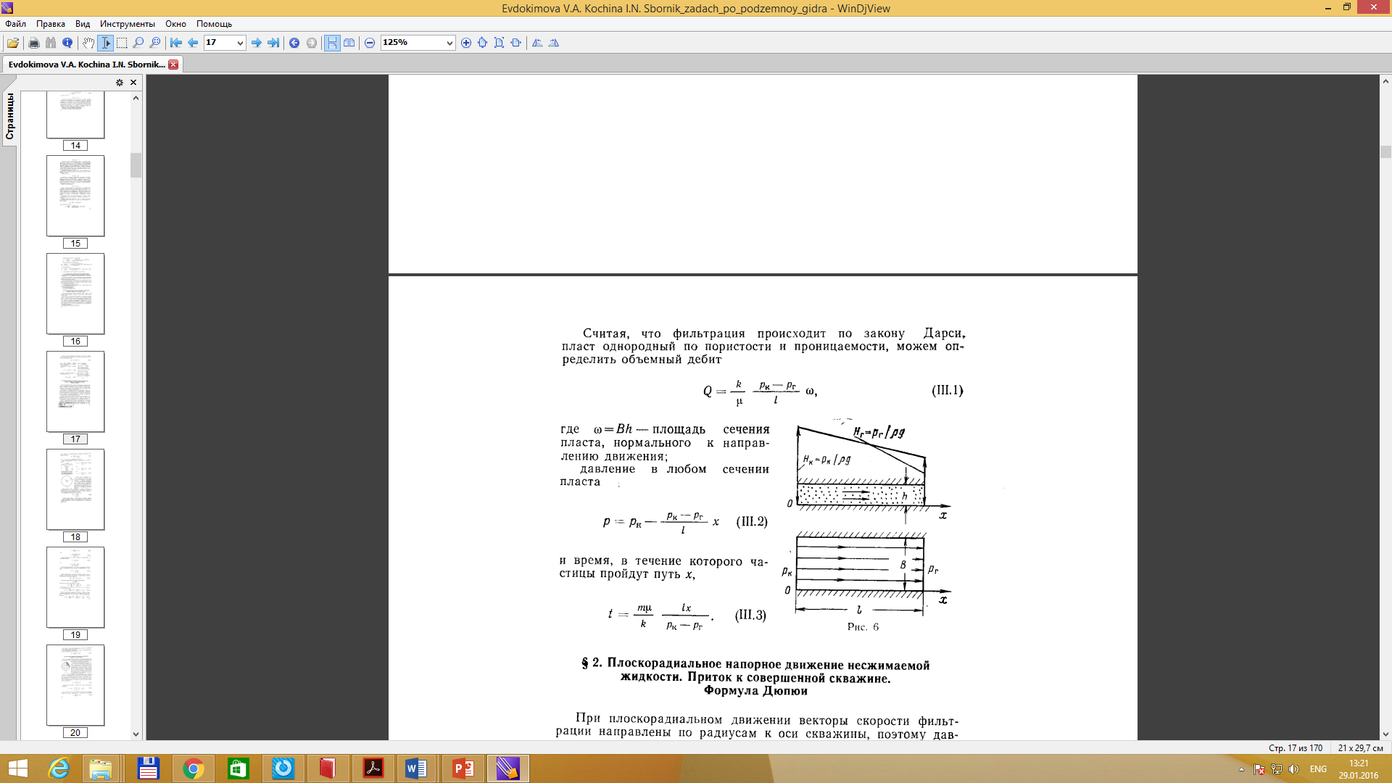

where ω=Bh – cross section area, normal to the flow direction. Pressure in any section is defined as
Time of particle which pass through x-distance is
Radial Flow

In case of radial flow the velocity vector is directed towards the well. Thus pressure and velocity are the function of r coordinate. Because fluids move toward the well from all directions and coverage at the wellbore, the term radial flow is given to characterize the flow of fluid into the wellbore. As an example of such flow we will consider flow towards the hydrodynamical perfect well in layer.

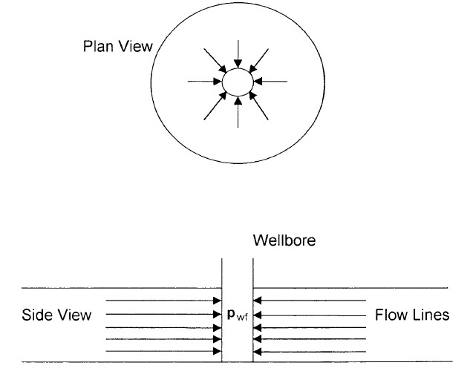

Figure-3. Ideal radial flow into a wellbore.
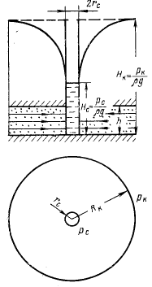

Figure -4. Қысымның
депрессиялық қисығы

Radial Flow of Incompressible Fluids

Let’s consider Radial Flow. rw – wellbore radius, pw – bottomhole pressure,
re – external radius, pe – external pressure. Darcy’s equation can be used to determine the flow rate at any radius r: 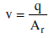 , surface area of a cylinder 2πrh

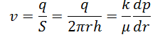
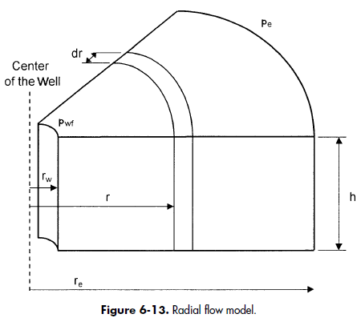

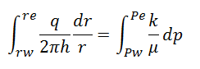

Dupuit’s formula

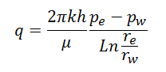

-
Dupuit’s formula:
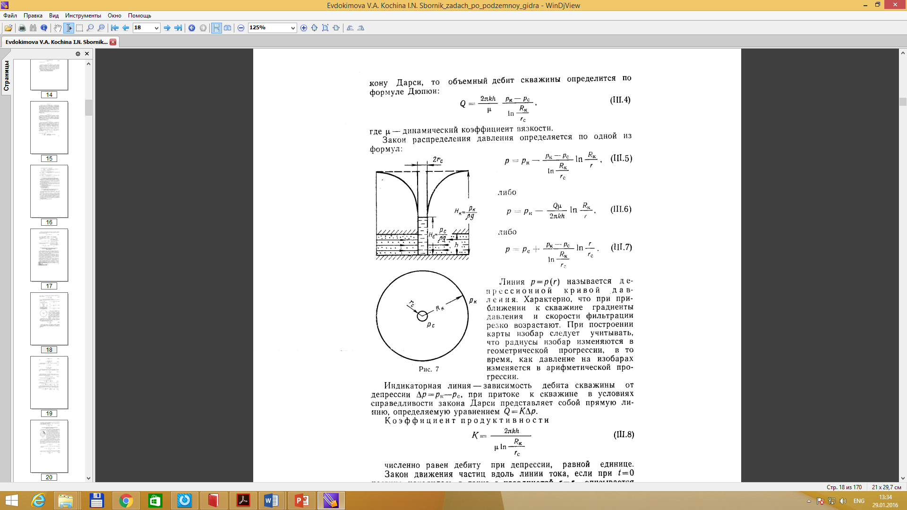
Presseure distribution in layer is defined by one of the following formua:

Q

r2
r
1

b

h2 h1

Qw
2πT

r2 dr r
∫
r
1

h2
= ∫ dh
h1

As we approach the well the
rings get smaller. A is smaller
but Q is the

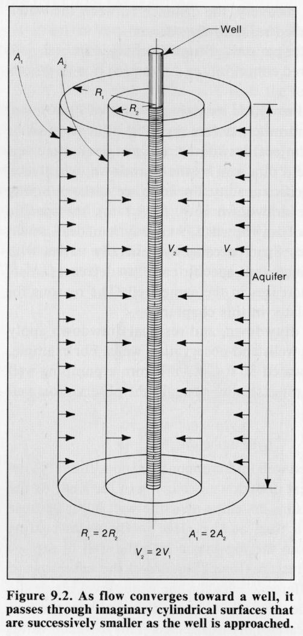

(Driscoll, 1986)
same, so dh dl
must increase.

Spherical and Hemispherical Flow

Depending upon the type of wellbore completion configuration, it is possible to have a spherical or hemispherical flow near the wellbore. A well with a limited perforated interval could result in spherical flow in the vicinity of the perforations. A well that only partially penetrates the pay zone, could result in hemispherical flow.


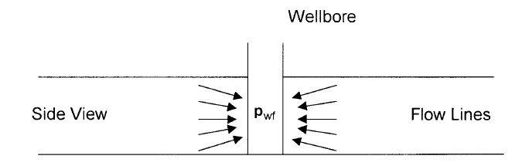

Figure-5. Spherical flow due to limited entry. Figure-6. Hemispherical flow in a partially
penetrating well.

